Assessing Representation Protected Area

Assessing Representation of Remote Sensing Derived Forest Structure and Land Cover Across a Network of Protected Areas

Evan R. Muise1,✉, Nicholas C. Coops1, Txomin Hermosilla2, and Stephen S. Ban3

Open Research Statement: Data are published and publicly available, with those items properly cited. 30m spatial coverages of the Landsat layers used in this manuscript are available at <https://opendata.nfis.org/mapserver/nfis-change_eng.html> and were clipped to British Columbia before analysis. Details on their creation are available in the Landsat Derived datasets section. Protected areas were obtained from the Canadian protected and conserved areas database (available at <https://www.canada.ca/en/environment-climate-change/services/national-wildlife-areas/protected-conserved-areas-database.html>), and were filtered to those located in British Columbia as well as using the criteria described in the Data section of the manuscript, and the **bcmaps** R package was used to obtain BEC zone and subzone boundaries. All code used for data manipulation and analysis is available at <https://zenodo.org/badge/latestdoi/350797384> or <https://github.com/emuise/bcparks_ei/releases/tag/submission>.

1 Integrated Remote Sensing Studio, Department of Forest Resource Management, University of British Columbia, 2424 Main Mall, Vancouver, British Columbia, V6T 1Z4, Canada  
2 Canadian Forest Service (Pacific Forestry Centre), Natural Resources Canada, 506 West Burnside Road, Victoria, British Columbia V8Z 1M5, Canada  
3 BC Parks, Ministry of Environment and Climate Change Strategy, PO Box 9360 Stn Prov Govt Victoria, British Columbia, V8V 9M2 Canada.

✉ Correspondence: [Evan R. Muise <[evanmuis@student.ubc.ca](mailto:evanmuis@student.ubc.ca)>](mailto:evanmuis@student.ubc.ca)

**Abstract:** Protected areas (PA) are an effective means of conserving biodiversity and protecting suites of valuable ecosystem services. Currently, many nations and international governments use proportional area protected as a critical metric for assessing progress towards biodiversity conservation. However, this and other common metrics do not assess the effectiveness of PA networks, nor do they assess how representative PA are of the ecosystems they aim to protect. Topography, stand structure, and land cover are all key drivers of biodiversity within forest environments, and are well suited as indicators to assess the representation of PA. Here we examine the protected area network in British Columbia, Canada, through these drivers derived from freely available data and remote sensing products across the provincial biogeoclimatic ecosystem classification system. We examine biases in the protected area network by elevation, forest disturbances, and forest structural attributes, including height, cover, and biomass by comparing a random sample of protected and unprotected pixels. Results indicate that PA are commonly biased towards high elevation and alpine land covers, and that forest structural attributes of the park network are often significantly different in protected vs unprotected areas (426 out of 496 forest structural attributes found to be different; p < 0.01). Analysis of forest structural attributes suggests that establishing additional PA could ensure representation of various forest structure regimes across British Columbia’s ecosystems. We conclude that these approaches using free and open remote sensing data are highly transferable, and can be accomplished using consistent datasets to assess PA representations globally.

**Keywords:** Protected Areas, Remote Sensing, Forest Structure, Forest Disturbances, Land Cover, Ecological Classifications

# Introduction

Protected areas (hereafter PA) are an integral component of biological conservation, designed to preserve ecosystem services and biodiversity both inside the PA and in some cases the surrounding regions (Chape et al. 2005, Watson et al. 2014). In recent decades, there has been a growing consensus of the need to conserve varying portions of the terrestrial area of the globe, with areal goals increasing over time (CBD 2004, 2010). In the 2010s, the Aichi biodiversity target sought to conserve 17% of the terrestrial and 10% of the marine area of the globe (CBD 2010). Nationwide, the Canadian government has set the goal of protecting 25% of Canada’s terrestrial area by 2025 (ECCC 2021). While increasing proportional ecosystem protection does in turn aid conservation, it does not guarantee the representativeness of the entire ecosystem, nor that all biodiversity within the PA will be effectively conserved (Hazen and Anthamatten 2004).

Many conservation goals, both global and regional, are commonly based on the proportion of area protected, at least partly due to its ease of use and calculation (Brooks et al. 2004, CBD 2010). However, while the area protected is a simple metric to report, other metrics can be more informative, with the potential to convey how effective a given PA is for protecting the inherent ecosystem services or biodiversity in the area (Chape et al. 2005, Butchart et al. 2015, Maxwell et al. 2020). Beyond areal extent, it is also relevant to consider the biases in PA placement, which are frequently located in fiscally cheaper, low productivity regions both globally (Joppa and Pfaff 2009, Venter et al. 2014, Venter et al. 2018) and regionally, as is the case in British Columbia (BC), Canada (Hamann et al. 2005, Environmental Reporting BC 2016, Wang et al. 2020). The areal protection targets currently in place are much lower than what research would indicate is necessary to adequately protect biodiversity (Dinerstein et al. 2017, Dinerstein et al. 2019).

In response to the proportion protected approach, a number of other methodologies have been developed to evaluate the effectiveness of PAs before these larger global targets have been met (Parrish et al. 2003, Gaston et al. 2006, 2008, Hansen and Phillips 2018, Bolton et al. 2019). One recently identified concept in Canadian park management is ecological integrity. Ecological integrity is defined as an ecosystem having the expected “living and non-living pieces for the region,” and where ecological processes occur at the expected frequency and intensity for the region (Parks Canada 2019). Many potential ecological integrity indicators have been examined to capture biodiversity related processes within PA (Hansen and Phillips 2018; Hansen et al., 2021). These indicators can then be interpreted manually or automatically, most often through examining temporal trends within the PA or by comparing the indicators to areas in known healthy reference ecosystems (Woodley 1993).

Frequently, comparisons between PA and unprotected areas (UA) have been drawn in order to assess PA performance and health (Defries et al. 2005). This allows for the PA or PA network to be taken in context of surrounding and/or similar ecosystems (Wiens et al. 2009). There are, however, challenges associated with comparing the effectiveness of PA directly with UA. It can be difficult to identify suitable UA for comparison due to the increased prevalence of human pressure in UA (Geldmann et al., 2019), and the bias for PA to be in areas that would not have faced increased human pressure due to their remoteness (Joppa and Pfaff, 2009).

Ferraro (2009) prescribed the use of the counterfactual method based on comparing the outcomes following PA implementation with what would have happened if the PA was not implemented. The counterfactual method is widely used as a more accurate method for assessing protected area management effectiveness (Coad et al., 2015, Geldmann et al., 2019, Eklund et al, 2019, Terraube et al., 2020). This method is frequently employed by using matching methods, where treatment and control samples are similar with regards to topography, climate, land cover, or others, to select UA which directly correspond to the PA being analyzed (Geldmann et al., 2019, Ribas et al., 2020). Collecting field data across both the PA and its counterfactual UA is often time-and-cost prohibitive. Consequently, the increasing prevalence of freely available imagery has led to satellite remote sensing becoming an essential tool for PA monitoring (Nagendra et al. 2013).

The opening of the Landsat archive in 2008 (Wulder et al. 2012a) has played a significant role in the use of satellite imagery in conservation monitoring (Nagendra 2008, Turner et al. 2015). The availability of 30-m spatial resolution data since 1984 allows for assessment of temporal trends in satellite derived indicators (Nagendra et al. 2013, Hansen and Phillips 2018, Bolton et al. 2019), while the global coverage allows for comparisons between similar and differing ecosystems (Nagendra 2008, Wulder et al. 2012a). Leveraging free and open-source optical remote sensing data products has allowed users to increasingly undertake comparisons across an entire jurisdiction’s PA network (Fraser et al. 2009, Soverel et al. 2010, Pôças et al. 2011, Bolton et al. 2019, Skidmore et al. 2021), comparing them to ecologically similar UA (Turner et al. 2015, Buchanan et al. 2018). These comparisons allow for an assessment of the effectiveness of a given PA or the entire PA network at representing regional biodiversity trends (Soverel et al. 2010, Turner et al. 2015, Bolton et al. 2019).

Optical remote sensing technologies have offered a key approach to deriving indicators (Nagendra 2008, Fraser et al. 2009, Soverel et al. 2010, Burkhard et al. 2012, Pereira et al. 2013, Bolton et al. 2019) and detecting key terrestrial processes (Turner et al. 2003) to assess PA effectiveness at conserving ecological integrity (Nagendra 2001, Nagendra et al. 2013). These indicators derived from remote sensing technologies can be categorized and monitored at broad spatial extents and across temporal scales. Commonly used indicators include land cover proportion (e.g., forest type, wetland, and unvegetated; Parmenter et al. 2003, Olthof et al. 2006), tree species (Nagendra 2001), habitat classification (McDermid et al. 2005, Lucas et al. 2011), spectral information (Feeley et al. 2005, Gillespie 2005, Nagendra et al. 2010), spectral heterogeneity (Rocchini et al. 2010), and ecosystem structure (Cohen and Goward 2004, Goetz et al. 2007, Soverel et al. 2010, Pôças et al. 2011) and function (Skidmore et al. 2021). Moreover, remote sensing technologies enable the monitoring of terrestrial processes, such as natural and anthropogenic disturbance regimes (Kerr and Ostrovsky 2003, Alsdorf et al. 2007, Hermosilla et al. 2015b, Bolton et al. 2019), alongside biogeochemical cycles (Myneni et al. 2001), vegetation productivity (Running et al. 2004), and vegetation dynamics (Zhang et al. 2003). Diversity in forest structural attribute measurements, often derived from light detection and ranging (lidar) is also a strong indicator of biodiversity, providing habitat, influencing food quality, and mediating microclimates (Gao et al. 2014, Guo et al. 2017).

Lidar enables the accurate characterization of treed vegetation structure (e.g. canopy height, canopy cover, basal area) across forested areas by measuring the time it takes for an emitted pulse of light to return to the sensor (Lim et al. 2003). While the natural variation in vertical and horizontal forest structure has been extensively explored using lidar, comparisons between PA and UA have been less frequently drawn using these methods when compared to optical remote sensing (Nagendra et al. 2013). The lack of previous comparisons has likely been due to the frequently limited extents of lidar acquisitions, a problem which has recently been solved by generating wall-to-wall metrics. These wall-to-wall metrics can be created by combining lidar data with times series of Landsat data, generating forest structural attributes across large regions and even entire countries (Wulder et al. 2012b, Matasci et al. 2018a).

As Canada progresses towards the national goal of 25% of terrestrial area protected by 2025, there is a growing need to better understand how PA compare to UA with respect to location, ecological classifications, elevations, productivity, and forest structure. In this study, we (1) examine the hypothesis that BC’s PA network is biased towards high-elevation, low-productivity regions of the province using free and open remote sensing data products, and (2) identify underrepresented forest structures in PA in the province. To accomplish this, we examined the bias in PA placement by comparing ecoregional PA coverage and land cover classes by elevation, and disturbances by latitude across PA and UA in BC. We examine representative forest structural attributes by comparing the distribution of key indicators by ecological zone to determine the differences between PA and UA to find the most and least similar represented forest structures throughout the network. We conclude by highlighting the usefulness of these globally available, high quality, consistent, and transferable datasets and methods for assessing PA effectiveness.

# Methods

## Study Area

The province of British Columbia, Canada, covers 94.4 million ha, of which approximately 64% is forested (BC Ministry of Forests 2003), and encapsulates a wide variety of biomes and ecosystems. This diversity of ecosystems is in part due to the large area as well as variations in topography and climate. The existing Biogeoclimatic Ecosystem Classification (BEC) system disaggregates BC ecosystems into zones (Pojar et al. 1987). The broadest classification delineates 16 zones, which are further broken down into subzones, variants, and phases based on microclimate, precipitation, and topography (Pojar et al. 1987, Meidinger and Pojar 1991). As a result, BEC zones vary widely in size (ranging from 0.25 million ha to 17.5 million ha), and in number of subzones (from 1 to 43; see Table 1).

Both the BC (BC Parks 2012) and Canada-wide (Government of Canada, 2019) PA mandates commit to conserving ecological integrity across the network. The PA network in BC is designed to serve both ecological conservation and human recreation aims (BC Parks 2012) and consists of a network of PA and PA complexes (multiple nearby PA which share the same conservation goals), with large variations in size, ranging from 0.02 to 987,899 ha (Figure 1).

## Data

### Biogeoclimatic Ecosystem Classification and Protected Areas

Boundaries for BEC zones and subzones were acquired using the **bcmaps** R package (Teucher et al. 2021). Two BEC subzones were entirely subsumed by PA (Boreal White and Black Spruce - Very Wet Cool and Spruce – Willow – Birch - Very Wet Cool Shrub), whereas the Sub-Boreal Pine – Spruce - Moist Cool subzone has no PA representation.

Boundaries for all PA in BC were obtained from the Canadian Protected and Conserved Areas Database (available from <https://cws-scf.ca/CPCAD-BDCAPC_Dec2020.gdb.zip>), current as of December 2020, and includes the International Union for Conservation of Nature (IUCN) classification for each PA. PA were selected for analysis following the criteria outlined in Bolton et al. (2019). Only parks which belonged to IUCN classes Ia, Ib, II, and IV were selected, as these categories are considered strictly protected for conservation purposes, and exclude monuments, and areas which can include anthropogenic disturbances caused by natural resource development. PA smaller than 100 ha in size were also excluded from the analysis, as these mainly occurred in urbanized areas. After selection, 745 suitable parks managed under various jurisdictions (provincial, federal, NGOs), comprising 15.4% of the total terrestrial area of British Columbia, were studied. An equal sample of pixels equal to the area of PA or UA - whichever was lower - was randomly selected from both PA and UA for each BEC subzone. This sampling regime follows the counterfactual approach, accounting for bias in topography, climate, and climax species due to the methods used to delineate BEC zones and subzones (Pojar et al. 1987).

### Digital Elevation Model

The Advanced Spaceborne Thermal Emission and Reflection Radiometer (ASTER) digital elevation model (GDEM V2, 30 m) was used to examine biases in protected area land cover and ecological classification by elevation (Tachikawa et al. 2011).

### Landsat derived datasets

Land cover, forest disturbances, and forest structural attributes for BC were derived from the annual Landsat best-available-pixel (BAP) composites from 1984 to 2019 at 30-m spatial resolution generated using the Composite2Change (C2C) approach (Hermosilla et al. 2016). These composites are generated by annually selecting the optimal observations, free from atmospheric effects (haze, clouds, cloud shadows), for each pixel from the catalog of available Landsat-5 Thematic Mapper (TM), Landsat-7 Enhanced Thematic Mapper Plus (ETM+), and Landsat-8 Operational Land Imager (OLI) imagery acquired during Canada’s growing season using the scoring functions defined in White et al. (2014). The annual BAP composites are further refined by applying a spectral trend analysis over the Normalized Burn Ratio (NBR) at pixel level in order to remove unscreened noise, detect changes and fill data gaps with temporally-interpolated values, resulting in annual, gap-free, surface-reflectance image composites (Hermosilla et al. 2015b). During this process, forest disturbances are detected, characterized and attributed to a disturbance agent (i.e., wildfire, harvest, non-stand replacing disturbances) using a Random Forests classification model via the object-based analysis approach (Hermosilla et al. 2015a) with an overall accuracy of 92% ±2% (Hermosilla et al. 2016).

Annual land cover information for Canada was produced using the BAP composites following the Virtual Land Cover Engine framework (Hermosilla et al. 2018). This framework integrates post-classification probabilities, forest disturbance information and forest successional knowledge with a Hidden Markov Model to ensure logical land cover transitions between years. The classification comprises 12 land cover classes organized as either non-vegetated or vegetated. Non-vegetated classes included water, snow/ice, rock/rubble, and exposed/barren land. Vegetated land cover classes discriminated among non-treed and treed vegetation (land-cover level). Vegetated non-treed classes comprised bryoids, herbs, wetland, and shrubs. Vegetated treed land cover classes included wetland-treed, coniferous, broadleaf, and mixed wood. Independent validation of the land cover maps indicated an overall accuracy of 70.3% ± 2.5%.

Wall-to-wall, 30-m forest structure metrics (i.e., Lorey’s height, total aboveground biomass, elevation covariance, and canopy cover) were also annually derived from the BAP composites using the imputation method described in Matasci et al. (2018a, 2018b). This method uses lidar and field plot data to estimate forest structure metrics from topographic and Landsat spectral predictors, using a k-Nearest Neighbor approach. Reported accuracy for the structure metrics indicated a RMSE% ranging from 24.5% to 65.8% and a R2 ranging from 0.125 to 0.699 (Matasci et al. 2018a).

Forest cover classes (deciduous, broadleaf, mixed-wood, and wetland-treed) were used to generate land cover masks to restrict the comparison of forest structural attributes to treed pixels. Pixels with harvest activity disturbances detected post-1985 were also removed from forest structural attribute rasters in both PA and UA, in order to restrict analysis to non-anthropogenically disturbed areas. All datasets are displayed in Figure 2.

## Analysis

To determine bias in ecosystem representation in BC’s PA network, we compared BEC zone, land cover, and disturbance proportions within and outside the PA network. We employ the counterfactual approach by examining BEC zone and land cover as a function of elevation, and secondly compiled disturbance rates on a latitudinal gradient across the province. Forest structural attributes were then examined at a finer ecosystem classification level, statistically comparing PA vs UA across similar ecosystems. Forest structural means across BEC zones were calculated to determine which forest structures need additional representation in the current BC PA network. All data manipulation and analysis was conducted in **R** version 4.1.1 (R Core Team 2021) or **Python** version 3.8.10 programming languages.

### Ecosystems, Land Cover, and Disturbances

BEC zones and land cover classifications were aggregated to both PA and UA in order to determine the proportion of each zone under the protected classifications, to examine progress towards the Aichi biodiversity targets. In this analysis, zones were used to examine categorical data (land cover and disturbance) for the period of 1984-2019. Land cover and BEC zones were further examined along an elevation gradient, at 50m increments. Histograms of area by elevation were generated in order to examine the areal magnitude alongside the proportional coverage of land cover and BEC zones. This allows us to examine the amount of area protected at each elevation, as well as the differences between PA and UA. Forest disturbances (including harvesting) were aggregated along a latitudinal gradient at increments of 0.5°.

### Forest Structural Attributes

T-tests for PA vs UA were conducted on all pixels selected for analysis by BEC subzone and forest structural attribute for 2015, and the Bonferroni correction was applied. The Bonferroni correction avoids spuriously significant results in multiple comparison tests by dividing the significant p-value (0.01) by the number of tests (Bonferroni 1936). Within each BEC zone, higher proportions of significant tests will indicate dissimilar subzones in each forest structural attribute. The mean values for PA and UA forest structural attributes were calculated, in order to examine the differences in their distribution and determine which structures and zones differ between PA and UA. Values were also converted into z-scores to determine the greatest standardized vector magnitude when comparing canopy cover, elevation covariance, and forest height between PA and UA.

# Results

### Ecosystems, Land Cover, and Disturbances

British Columbia’s ecosystems are protected at varying rates across the province (Figure 3). Of the 16 ecosystems present in BC, seven are protected at rates above the Aichi biodiversity target (17%). Only two zones (Boreal Altai Fescue Alpine and Interior Mountain-heather Alpine) are currently protected at rates above the Canadian 2025 protection targets (25%). Zones with Douglas-fir (*Pseudotsuga menziesii*) as dominant old-growth components (Coastal Douglas-fir and Interior Douglas-fir) are the least proportionally represented zones in British Columbia, with 4.9% and 6.4% protected, respectively (Figure 3).

As elevation increases in BC, increasing terrestrial area is protected within the PA network until ~4000m, upon which all terrestrial area is protected (Figure 4). When comparing between PA and UA, zones are protected at differing proportions. For both Figure 4 and 6, values across a given elevation show the proportion of that elevation represented by each BEC zone or land cover class in both (b) PA and (c) UA. Zones commonly found at high elevations, such as the Boreal Altai Fescue Alpine, are predominantly located in PA, however, little terrestrial area is found at these elevations. In low elevations, proportions of area protected also differ, with Coastal Western Hemlock having a large proportion of coverage in PA, while in UA, Boreal Black and White Spruce are underrepresented. Generally, the remaining ecosystems are found at similar rates in both PA and UA (Figure 4).

Protected land cover also varies by proportion (Figure 5). Non-vegetated classes of snow/ice, exposed/barren land, and rock/rubble have higher than average proportions protected while mixed wood and broadleaf land cover classes are underrepresented. All other classes are found at rates similar to the overall proportion of the province protected (~15%; Figure 5).

Similar to BEC zones (Figure 4), land cover also varies with elevation (Figure 6). Expectedly, snow/ice make up a large proportion of PA at higher elevations. At lower elevations in UA, mixed wood forest is a more common forest type than in PA, while wetland classes (wetland, wetland-treed) are less frequent in the 400-900m elevation range in UA compared to PA.

Figure 7 shows the elevation distributions of BEC zones and land cover classes. Generally, BEC zones are found at similar elevation profiles in both PA and UA. Alpine BEC zones (Interior Mountain-heather Alpine, Boreal Altai Fescue Alpine, and Coastal Mountain-heather Alpine) are found at similar elevations across PA and UA, while other zones such as Sub-Boreal Pine -- Spruce, Ponderosa Pine, and Bunchgrass vary in their elevation profiles. Land cover classes show differences in the wetland, wetland-treed, and mixed wood classes. The wetland classes are found at lower elevations in PA than UA, while the mixed wood class has more variation in PA.

Overall, the burned area of forested cells is similar between PA (2.5% overall) and UA (2.3%), while harvesting is much higher in UA (7.2%) than in PA (0.33%). Harvesting is more common at lower latitudes in UA than at higher latitudes. Fire shows similar, but not identical patterns across varying latitudes, with higher wildfire proportions at high latitudes and between 51-53°N (Figure 8).

### Forest Structural Attributes

Figure 9 shows the subzonal proportional significance (*p < 0.01*) grouped by ecosystem for the 496 comparisons of forest structural variables. Higher percentages confirm ecosystems which had increased number of dissimilar subzones for the specific indicator, and shows that at least half of all subzones in each ecosystem are significantly different (the exception being Ponderosa Pine, which consists of a single subzone that is not significantly different in canopy structure). Median proportional significance values for canopy height, canopy cover, and aboveground biomass are universally significantly different between PA and UA within the same ecosystem.

Forest structural attributes vary between PA and UA in BC (Figure 10). The largest differences between PA and UA are found in canopy structure in the Coastal Douglas-fir BEC zone, with the PA having much higher canopy structure values. As shown in Figure 9, forests are commonly significantly different when comparing PA vs UA across all attributes. When examining the forests on an BEC zone level, only one BEC zone has a >5% difference in vertical forest structure (co-efficient of variation in vegetation returns), six BEC zones have >5% difference in canopy cover, and five BEC zones have a >5% difference in canopy height. Ponderosa pine has large differences in canopy cover and canopy height (>5%), but minor differences in elevation covariance (only 0.25%; Table 2). PA in the Ponderosa Pine, Interior Mountain Heather Alpine, and Coastal Douglas-fir have more aboveground biomass than in UA in corresponding areas (Figure 10).

# Discussion

The recent global availability of freely available, open-source, consistent, and accurate remote sensing data products allow researchers to examine issues of representation of PA compared to UA, and regional ecosystems in novel ways (Soverel et al. 2010, Hansen and Phillips 2018, Bolton et al. 2019). Additionally, the capacity to track forest structural attributes, a key indicator of forest biodiversity (Guo et al. 2017), across wide swaths allows for informed decisions on potential locations of new PA which capture previously underrepresented forest structure conditions (Noss 1999). By applying this analysis to an entire PA network across BEC zones (or other ecological classifications), it becomes possible to determine the BEC zones needing additional representation (the proportional metric), as well as the types of forest structures that should be represented to ensure adequate biodiversity protection (Lemieux and Scott 2005).

Internationally, biodiversity preservation targets aim to protect a proportion of the total terrestrial area (CBD 2010). Frequently, new protected areas are placed in high-elevation, low-productivity ecosystems both globally (Joppa and Pfaff 2009, Venter et al. 2014, Venter et al. 2018), and in BC, as confirmed by our analysis of ecosystem (Figure 3), and land cover (Figure 5) proportions. Alpine ecosystems are more commonly protected (Figure 3), as are the land covers commonly present within them (rock/rubble, snow/ice, exposed/barren land; Figure 5). As elevation increases, these ecosystems and land covers begin to dominate the proportional representation (see Figure 4 and Figure 6). Differences between elevation profiles in land cover classes and BEC zones were also found, with the largest difference being that wetland classes were found at lower elevations in PA (Figure 7).

In high elevation ecosystems, Boreal Altai Fescue Alpine dominates the PA proportions above 3000 m, replacing the Coastal Mountain-Heather Alpine ecosystem found in UA (Figure 4). These zones were both protected at rates above the average (Figure 3), and above the Aichi biodiversity targets. Interior mountain-heather alpine had large differences in canopy cover and canopy height, while Boreal Altai Fescue Alpine only showed large differences in height. The Coastal Mountain-heather Alpine did not any have large forest structural attribute differences (Table 2).

Distribution of disturbances followed a similar pattern to that reported by Bolton et al. (2019). Thus, the area affected by wildfires is comparable between PA and UA and at mid latitudes (51-53°N), while harvesting activity is more prevalent in UA and at low latitudes (Figure 8).

Our analysis shows that the majority of structural attributes were significantly different between the protected and unprotected forest stands across BEC subzones (Figure 9). In the south, Coastal Douglas-fir, a zone with a single subzone, had the large variation between PA and UA in two of four forest structural attributes examined. The unprotected forests were significantly less tall, had significantly less canopy cover, and significantly higher elevation covariance (vertical forest structure; Figure 10). In addition, it was the least protected BEC zone by area, with only 4.9% of the total terrestrial area protected. In this specific BEC zone, not only does additional area need to be protected to meet national goals, different forest structures need to be included in new protected areas (Paillet et al. 2010).

Utilizing this information on the proportion of BEC zones protected (Figure 3), as well as their forest structural attributes (Table 2), it is possible to identify which forest structures need to be added to the PA network in BC. Those BEC zones with large differences (identified as being >5% change from PA to UA) suggest additional protection would encapsulate these underrepresented forest structures. For example: the forests in the Bunchgrass zone have large differences in both canopy cover and canopy height, with the PA having larger values in both attributes (Table 2). New PA in this BEC zone could contain forests with shorter and more open forests. A future avenue of research could be to incorporate forest structural attributes into spatially optimized PA placement approaches (Christensen et al. 2009).

The advent of free and open global datasets can allow for the monitoring of protected area health across the globe (Nagendra et al. 2013). Analyzing large amounts of free and open data using open-source software approaches offers previously unseen perspectives into protected area representativeness. There are some challenges associated with this, namely: optical imagery archives being scarce in some regions due to imagery acquisition policies (Wulder et al. 2016), clouds and atmospheric interference (Li and Chen 2020), lack of aerial lidar data available, and varying land cover legends used in differing regions and mapping products (Herold et al. 2008). New data and satellite missions are being introduced that can meet these challenges at a spatial resolution of 30 m or less such as Landsat-9 and Sentinel-2, as well as spaceborne lidar such as GEDI (Dubayah et al. 2020) and ICESat-2 (Neuenschwander et al. 2020), which can provide global coverage of various forest structural attributes (Potapov et al. 2021) through similar imputation methods to Matasci et al. (2018a), global land cover maps (Potapov et al. 2020, Zanaga et al. 2021), and forest disturbance maps (Hansen et al. 2013). These novel datasets provide clear opportunities for regional to global analyses of PA vs UA to be conducted concerning forest structure.

Future research monitoring protected area health using satellite remote sensing could focus on implementing essential biodiversity variables (Pereira et al. 2013) into their monitoring scheme. Advancing research towards these variables would not only benefit PA monitoring projects, but also biodiversity monitoring projects across the globe. Beyond this, examining the recovery of forest structural attribute following disturbances in both PA and UA could assess the effectiveness of PA for promoting regeneration.

# Conclusion

In conclusion, we identified biases in the BC PA network for PA to be placed in high-elevation BEC zones, commonly dominated by low-productivity land covers. We examined the disturbance regimes of PA vs UA by latitude, finding that wildfires are similar, while harvesting differs across the province. We then compared the forest structural attributes across all BEC subzones, finding that the majority of subzones have significantly different forest structures. Beyond this, we identified BEC zones with large variation in mean forest structural attributes. When new PA locations are decided upon in BC, they could take forest structure into consideration, as wall-to-wall coverage of forest structural attributes becomes available. Novel datasets can allow this methodology to be applied across large regions, in order to identify PA biases and underrepresented forest structures.

# Acknowledgments

This research was funded through the BC Parks Living Lab Program for Climate Change and Conservation (grant ID: TP21JHQ011) and in part by NSERC support of Coops (RGPIN-2018-03851). Remote sensing data products utilized in this research are free and open and available for download at: <https://ca.nfis.org/maps_eng.html>. We thank Dr Michael Wulder and Dr Joanne White for development and early access to these National Terrestrial Ecosystem Mapping System (NTEMS) products. We also thank an anonymous reviewer for their helpful comments which improved the manuscript.

# Literature Cited

Alsdorf, D. E., E. Rodriguez, and D. P. Lettenmaier. 2007. Measuring surface water from space. Reviews of Geophysics 45:RG2002.

BC Ministry of Forests. 2003. British Columbia’s forests and their management.

BC Parks. 2012. Ecological Integrity in British Columbia’s Parks and Protected Areas.

Bolton, D. K., N. C. Coops, T. Hermosilla, M. A. Wulder, J. C. White, and C. J. Ferster. 2019. Uncovering regional variability in disturbance trends between parks and greater park ecosystems across Canada (1985). Scientific Reports 9:1323.

Bonferroni, C. E. 1936. Teoria statistica delle classi e calcolo delle probabilità. Pages 3–62.

Brooks, T. M., M. I. Bakarr, T. Boucher, G. A. B. Da Fonseca, C. Hilton-Taylor, J. M. Hoekstra, T. Moritz, S. Olivieri, J. Parrish, R. L. Pressey, A. S. L. Rodrigues, W. Sechrest, A. Stattersfield, W. Strahm, and S. N. Stuart. 2004. Coverage Provided by the Global Protected-Area System: Is It Enough? BioScience 54:1081.

Buchanan, G. M., A. E. Beresford, M. Hebblewhite, F. J. Escobedo, H. M. D. Klerk, P. F. Donald, P. Escribano, L. P. Koh, J. Martínez-López, N. Pettorelli, A. K. Skidmore, Z. Szantoi, K. Tabor, M. Wegmann, and S. Wich. 2018. Free satellite data key to conservation. Science 361:139–140.

Burkhard, B., F. Kroll, S. Nedkov, and F. Müller. 2012. Mapping ecosystem service supply, demand and budgets. Ecological Indicators 21:17–29.

Butchart, S. H. M., M. Clarke, R. J. Smith, R. E. Sykes, J. P. W. Scharlemann, M. Harfoot, G. M. Buchanan, A. Angulo, A. Balmford, B. Bertzky, T. M. Brooks, K. E. Carpenter, M. T. Comeros-Raynal, J. Cornell, G. F. Ficetola, L. D. C. Fishpool, R. A. Fuller, J. Geldmann, H. Harwell, C. Hilton-Taylor, M. Hoffmann, A. Joolia, L. Joppa, N. Kingston, I. May, A. Milam, B. Polidoro, G. Ralph, N. Richman, C. Rondinini, D. B. Segan, B. Skolnik, M. D. Spalding, S. N. Stuart, A. Symes, J. Taylor, P. Visconti, J. E. M. Watson, L. Wood, and N. D. Burgess. 2015. Shortfalls and Solutions for Meeting National and Global Conservation Area Targets. Conservation Letters 8:329–337.

CBD. 2004. CoP 7 decision VII/30. Strategic plan: future evaluation of progress. Goal 1 promote the conservation of the biological diversity of ecosystems, habitats and biomes; Target 1.1.

CBD. 2010. The strategic plan for biodiversity 2011-2020 and the Aichi biodiversity targets.

Chape, S., J. Harrison, M. Spalding, and I. Lysenko. 2005. Measuring the extent and effectiveness of protected areas as an indicator for meeting global biodiversity targets. Philosophical Transactions of the Royal Society B: Biological Sciences 360:443–455.

Christensen, V., Z. Ferdaña, and J. Steenbeek. 2009. Spatial optimization of protected area placement incorporating ecological, social and economical criteria. Ecological Modelling 220:2583–2593.

Coad, L., F. Leverington, K. Knights, J. Geldmann, A. Eassom, V. Kapos, N. Kingston, M. de Lima, C. Zamora, I. Cuardros, C. Nolte, N. D. Burgess, and M. Hockings. 2015. Measuring impact of protected area management interventions: Current and future use of the global database of protected area management effectiveness. Philosophical Transactions of the Royal Society B: Biological Sciences 370:20140281.

Cohen, W. B., and S. N. Goward. 2004. Landsat’s role in ecological applications of remote sensing. Bioscience 54:535–545.

Defries, R., A. Hansen, A. Newton, and M. Hansen. 2005. Increasing isolation of protected areas in tropical forests over the past twenty years. Ecological Applications 15:19–26.

Dinerstein, E., D. Olson, A. Joshi, C. Vynne, N. D. Burgess, E. Wikramanayake, N. Hahn, S. Palminteri, P. Hedao, R. Noss, M. Hansen, H. Locke, E. C. Ellis, B. Jones, C. V. Barber, R. Hayes, C. Kormos, V. Martin, E. Crist, W. Sechrest, L. Price, J. E. M. Baillie, D. Weeden, K. Suckling, C. Davis, N. Sizer, R. Moore, D. Thau, T. Birch, P. Potapov, S. Turubanova, A. Tyukavina, N. de Souza, L. Pintea, J. C. Brito, O. A. Llewellyn, A. G. Miller, A. Patzelt, S. A. Ghazanfar, J. Timberlake, H. Klöser, Y. Shennan-Farpón, R. Kindt, J.-P. B. Lillesø, P. van Breugel, L. Graudal, M. Voge, K. F. Al-Shammari, and M. Saleem. 2017. An Ecoregion-Based Approach to Protecting Half the Terrestrial Realm. BioScience 67:534–545.

Dinerstein, E., C. Vynne, E. Sala, A. R. Joshi, S. Fernando, T. E. Lovejoy, J. Mayorga, D. Olson, G. P. Asner, J. E. M. Baillie, N. D. Burgess, K. Burkart, R. F. Noss, Y. P. Zhang, A. Baccini, T. Birch, N. Hahn, L. N. Joppa, and E. Wikramanayake. 2019. A Global Deal For Nature: Guiding principles, milestones, and targets. Science Advances 5:eaaw2869.

Dubayah, R., J. B. Blair, S. Goetz, L. Fatoyinbo, M. Hansen, S. Healey, M. Hofton, G. Hurtt, J. Kellner, S. Luthcke, J. Armston, H. Tang, L. Duncanson, S. Hancock, P. Jantz, S. Marselis, P. L. Patterson, W. Qi, and C. Silva. 2020. The Global Ecosystem Dynamics Investigation: High-resolution laser ranging of the Earth’s forests and topography. Science of Remote Sensing 1:100002.

ECCC. 2021, May 3. Canada Target 1 Challenge.

Eklund, J., L. Coad, J. Geldmann, and M. Cabeza. 2019. What constitutes a useful measure of protected area effectiveness? A case study of management inputs and protected area impacts in Madagascar. Conservation Science and Practice 1:e107.

Environmental Reporting BC. 2016. Protected Lands and Waters in British Columbia. http://www.env.gov.bc.ca/soe/indicators/land/protected-lands-and-waters.html.

Feeley, K. J., T. W. Gillespie, and J. W. Terborgh. 2005. The Utility of Spectral Indices from Landsat ETM+ for Measuring the Structure and Composition of Tropical Dry Forests. Biotropica 37:508–519.

Ferraro, P. J. 2009. Counterfactual thinking and impact evaluation in environmental policy. New Directions for Evaluation 2009:75–84.

Fraser, R. H., I. Olthof, and D. Pouliot. 2009. Monitoring land cover change and ecological integrity in Canada’s national parks. Remote Sensing of Environment 113:1397–1409.

Gao, T., M. Hedblom, T. Emilsson, and A. B. Nielsen. 2014. The role of forest stand structure as biodiversity indicator. Forest Ecology and Management 330:82–93.

Gaston, K. J., K. Charman, S. F. Jackson, P. R. Armsworth, A. Bonn, R. A. Briers, C. S. Q. Callaghan, R. Catchpole, J. Hopkins, W. E. Kunin, J. Latham, P. Opdam, R. Stoneman, D. A. Stroud, and R. Tratt. 2006. The ecological effectiveness of protected areas: The United Kingdom. Biological Conservation 132:76–87.

Gaston, K. J., S. F. Jackson, L. Cantú-Salazar, and G. Cruz-Piñón. 2008. The Ecological Performance of Protected Areas. Annual Review of Ecology, Evolution, and Systematics 39:93–113.

Geldmann, J., A. Manica, N. D. Burgess, L. Coad, and A. Balmford. 2019. A global-level assessment of the effectiveness of protected areas at resisting anthropogenic pressures. Proceedings of the National Academy of Sciences 116:23209–23215.

Gillespie, T. W. 2005. Predicting Woody-Plant Species Richness in Tropical Dry Forests: A Case Study from South Florida, USA. Ecological Applications 15:27–37.

Goetz, S., D. Steinberg, R. Dubayah, and B. Blair. 2007. Laser remote sensing of canopy habitat heterogeneity as a predictor of bird species richness in an eastern temperate forest, USA. Remote Sensing of Environment 108:254–263.

Government of Canada. 2019, September 4. Canada National Park Act.

Guo, X., N. C. Coops, P. Tompalski, S. E. Nielsen, C. W. Bater, and J. John Stadt. 2017. Regional mapping of vegetation structure for biodiversity monitoring using airborne lidar data. Ecological Informatics 38:50–61.

Hamann, A., P. Smets, A. D. Yanchuk, and S. N. Aitken. 2005. An ecogeographic framework for in situ conservation of forest trees in British Columbia. Canadian Journal of Forest Research 35:2553–2561.

Hansen, A. J., B. P. Noble, J. Veneros, A. East, S. J. Goetz, C. Supples, J. E. M. Watson, P. A. Jantz, R. Pillay, W. Jetz, S. Ferrier, H. S. Grantham, T. D. Evans, J. Ervin, O. Venter, and A. L. S. Virnig. 2021. Toward monitoring forest ecosystem integrity within the post-2020 Global Biodiversity Framework. Conservation Letters 14:e12822.

Hansen, A. J., and L. Phillips. 2018. Trends in vital signs for Greater Yellowstone: Application of a Wildland Health Index. Ecosphere 9:e02380.

Hansen, M. C., P. V. Potapov, R. Moore, M. Hancher, S. A. Turubanova, A. Tyukavina, D. Thau, S. V. Stehman, S. J. Goetz, T. R. Loveland, A. Kommareddy, A. Egorov, L. Chini, C. O. Justice, and J. R. G. Townshend. 2013. High-Resolution Global Maps of 21st-Century Forest Cover Change. Science 342:850–853.

Hazen, H. D., and P. J. Anthamatten. 2004. Representation of ecological regions by protected areas at the global scale. Physical Geography 25:499–512.

Hermosilla, T., M. A. Wulder, J. C. White, N. C. Coops, and G. W. Hobart. 2015a. An integrated Landsat time series protocol for change detection and generation of annual gap-free surface reflectance composites. Remote Sensing of Environment 158:220–234.

Hermosilla, T., M. A. Wulder, J. C. White, N. C. Coops, and G. W. Hobart. 2015b. Regional detection, characterization, and attribution of annual forest change from 1984 to 2012 using Landsat-derived time-series metrics. Remote Sensing of Environment 170:121132.

Hermosilla, T., M. A. Wulder, J. C. White, N. C. Coops, and G. W. Hobart. 2018. Disturbance-Informed Annual Land Cover Classification Maps of Canada’s Forested Ecosystems for a 29-Year Landsat Time Series. Canadian Journal of Remote Sensing 44:67–87.

Hermosilla, T., M. A. Wulder, J. C. White, N. C. Coops, G. W. Hobart, and L. B. Campbell. 2016. Mass data processing of time series Landsat imagery: Pixels to data products for forest monitoring. International Journal of Digital Earth 9:1035–1054.

Herold, M., P. Mayaux, C. E. Woodcock, A. Baccini, and C. Schmullius. 2008. Some challenges in global land cover mapping: An assessment of agreement and accuracy in existing 1 km datasets. Remote Sensing of Environment 112:2538–2556.

Joppa, L. N., and A. Pfaff. 2009. High and Far: Biases in the Location of Protected Areas. PLOS ONE 4:e8273.

Kerr, J. T., and M. Ostrovsky. 2003. From space to species: ecological applications for remote sensing. Trends in Ecology & Evolution 18:299–305.

Lemieux, C. J., and D. J. Scott. 2005. Climate change, biodiversity conservation and protected area planning in Canada. The Canadian Geographer / Le Géographe Canadien 49:384–397.

Li, J., and B. Chen. 2020. Global Revisit Interval Analysis of Landsat-8 -9 and Sentinel-2A -2B Data for Terrestrial Monitoring. Sensors 20:6631.

Lim, K., P. Treitz, M. Wulder, B. St-Onge, and M. Flood. 2003. LiDAR remote sensing of forest structure. Progress in Physical Geography: Earth and Environment 27:88–106.

Lucas, R., K. Medcalf, A. Brown, P. Bunting, J. Breyer, D. Clewley, S. Keyworth, and P. Blackmore. 2011. Updating the Phase 1 habitat map of Wales, UK, using satellite sensor data. ISPRS Journal of Photogrammetry and Remote Sensing 66:81–102.

Matasci, G., T. Hermosilla, M. A. Wulder, J. C. White, N. C. Coops, G. W. Hobart, D. K. Bolton, P. Tompalski, and C. W. Bater. 2018a. Three decades of forest structural dynamics over Canada’s forested ecosystems using Landsat time-series and lidar plots. Remote Sensing of Environment 216:697–714.

Matasci, G., T. Hermosilla, M. A. Wulder, J. C. White, N. C. Coops, G. W. Hobart, and H. S. J. Zald. 2018b. Large-area mapping of Canadian boreal forest cover, height, biomass and other structural attributes using Landsat composites and lidar plots. Remote Sensing of Environment 209:90–106.

Maxwell, S. L., V. Cazalis, N. Dudley, M. Hoffmann, A. S. L. Rodrigues, S. Stolton, P. Visconti, S. Woodley, N. Kingston, E. Lewis, M. Maron, B. B. N. Strassburg, A. Wenger, H. D. Jonas, O. Venter, and J. E. M. Watson. 2020. Area-based conservation in the twenty-first century. Nature 586:217–227.

McDermid, G. J., S. E. Franklin, and E. F. LeDrew. 2005. Remote sensing for large-area habitat mapping. Progress in Physical Geography: Earth and Environment 29:449–474.

Meidinger, D. V., and J. Pojar, editors. 1991. Ecosystems of British Columbia. Research Branch, Ministry of Forests, Victoria, B.C.

Myneni, R. B., J. Dong, C. J. Tucker, R. K. Kaufmann, P. E. Kauppi, J. Liski, L. Zhou, V. Alexeyev, and M. K. Hughes. 2001. A large carbon sink in the woody biomass of northern forests. Proceedings of the National Academy of Sciences of the United States of America 98:14784–14789.

Nagendra, H. 2001. Using remote sensing to assess biodiversity. International Journal of Remote Sensing 22:2377–2400.

Nagendra, H. 2008. Do parks work? Impact of protected areas on land cover clearing. Ambio 37:330–337.

Nagendra, H., R. Lucas, J. P. Honrado, R. H. G. Jongman, C. Tarantino, M. Adamo, and P. Mairota. 2013. Remote sensing for conservation monitoring: Assessing protected areas, habitat extent, habitat condition, species diversity, and threats. Ecological Indicators 33:45–59.

Nagendra, H., D. Rocchini, R. Ghate, B. Sharma, and S. Pareeth. 2010. Assessing Plant Diversity in a Dry Tropical Forest: Comparing the Utility of Landsat and Ikonos Satellite Images. Remote Sensing 2:478–496.

Neuenschwander, A., E. Guenther, J. C. White, L. Duncanson, and P. Montesano. 2020. Validation of ICESat-2 terrain and canopy heights in boreal forests. Remote Sensing of Environment 251:112110.

Noss, R. F. 1999. Assessing and monitoring forest biodiversity: A suggested framework and indicators. Forest Ecology and Management 115:135–146.

Olthof, I., D. Pouliot, R. Fraser, A. Clouston, S. Wang, W. Chen, J. Orazietti, J. Poitevin, D. Mclennan, J. Kerr, and M. Sawada. 2006. Using Satellite Remote Sensing to Assess and Monitor Ecosystem Integrity and Climate Change in Canadas National Parks. 2006 IEEE International Symposium on Geoscience and Remote Sensing. IEEE.

Paillet, Y., L. Berges, J. Hjalten, P. Odor, C. Avon, M. Bernhardt-Roemermann, R.-J. Bijlsma, L. De Bruyn, M. Fuhr, U. Grandin, R. Kanka, L. Lundin, S. Luque, T. Magura, S. Matesanz, I. Meszaros, M.-. Teresa Sebastia, W. Schmidt, T. Standovar, B. Tothmeresz, A. Uotila, F. Valladares, K. Vellak, and R. Virtanen. 2010. Biodiversity differences between managed and unmanaged forests: Meta-analysis of species richness in Europe. Conservation Biology 24:101–112.

Parks Canada. 2019. Ecological Integrity. https://www.pc.gc.ca/en/nature/science/conservation/ie-ei.

Parmenter, A. W., A. Hansen, R. E. Kennedy, W. Cohen, U. Langner, R. Lawrence, B. Maxwell, A. Gallant, and R. Aspinall. 2003. Land use and land cover change in the Greater Yellowstone Ecosystem: 1975. Ecological Applications 13:687–703.

Parrish, J. D., D. P. Braun, and R. S. Unnasch. 2003. Are We Conserving What We Say We Are? Measuring Ecological Integrity within Protected Areas. BioScience 53:851.

Pereira, H. M., S. Ferrier, M. Walters, G. N. Geller, R. H. G. Jongman, R. J. Scholes, M. W. Bruford, N. Brummitt, S. H. M. Butchart, A. C. Cardoso, N. C. Coops, E. Dulloo, D. P. Faith, J. Freyhof, R. D. Gregory, C. Heip, R. Hoft, G. Hurtt, W. Jetz, D. S. Karp, M. A. McGeoch, D. Obura, Y. Onoda, N. Pettorelli, B. Reyers, R. Sayre, J. P. W. Scharlemann, S. N. Stuart, E. Turak, M. Walpole, and M. Wegmann. 2013. Essential Biodiversity Variables. Science 339:277–278.

Pojar, J., K. Klinka, and D. V. Meidinger. 1987. Biogeoclimatic ecosystem classification in British Columbia. Forest Ecology and Management 22:119–154.

Pôças, I., M. Cunha, and L. S. Pereira. 2011. Remote sensing based indicators of changes in a mountain rural landscape of Northeast Portugal. Applied Geography 31:871–880.

Potapov, P., M. C. Hansen, I. Kommareddy, A. Kommareddy, S. Turubanova, A. Pickens, B. Adusei, A. Tyukavina, and Q. Ying. 2020. Landsat Analysis Ready Data for Global Land Cover and Land Cover Change Mapping. Remote Sensing 12:426.

Potapov, P., X. Li, A. Hernandez-Serna, A. Tyukavina, M. C. Hansen, A. Kommareddy, A. Pickens, S. Turubanova, H. Tang, C. E. Silva, J. Armston, R. Dubayah, J. B. Blair, and M. Hofton. 2021. Mapping global forest canopy height through integration of GEDI and Landsat data. Remote Sensing of Environment 253:112165.

R Core Team. 2021. R: A language and environment for statistical computing. R Foundation for Statistical Computing, Vienna, Austria.

Ribas, L. G. dos S., R. L. Pressey, R. Loyola, and L. M. Bini. 2020. A global comparative analysis of impact evaluation methods in estimating the effectiveness of protected areas. Biological Conservation 246:108595.

Rocchini, D., N. Balkenhol, G. A. Carter, G. M. Foody, T. W. Gillespie, K. S. He, S. Kark, N. Levin, K. Lucas, M. Luoto, H. Nagendra, J. Oldeland, C. Ricotta, J. Southworth, and M. Neteler. 2010. Remotely sensed spectral heterogeneity as a proxy of species diversity: Recent advances and open challenges. Ecological Informatics 5:318–329.

Running, S. W., R. R. Nemani, F. A. Heinsch, M. S. Zhao, M. Reeves, and H. Hashimoto. 2004. A continuous satellite-derived measure of global terrestrial primary production. Bioscience 54:547–560.

Skidmore, A. K., N. C. Coops, E. Neinavaz, A. Ali, M. E. Schaepman, M. Paganini, W. D. Kissling, P. Vihervaara, R. Darvishzadeh, H. Feilhauer, M. Fernandez, N. Fernández, N. Gorelick, I. Geijzendorffer, U. Heiden, M. Heurich, D. Hobern, S. Holzwarth, F. E. Muller-Karger, R. Van De Kerchove, A. Lausch, P. J. Leitão, M. C. Lock, C. A. Mücher, B. O’Connor, D. Rocchini, W. Turner, J. K. Vis, T. Wang, M. Wegmann, and V. Wingate. 2021. Priority list of biodiversity metrics to observe from space. Nature Ecology & Evolution.

Soverel, N. O., N. C. Coops, J. C. White, and M. A. Wulder. 2010. Characterizing the forest fragmentation of Canada’s national parks. Environmental Monitoring and Assessment 164:481–499.

Tachikawa, T., M. Kaku, A. Iwasaki, D. B. Gesch, M. J. Oimoen, Z. Zhang, J. J. Danielson, T. Krieger, B. Curtis, J. Haase, M. Abrams, and C. Carabajal. 2011. ASTER global digital elevation model version 2 - summary of validation results. Page 27.

Teucher, A., S. Hazlitt, and S. Albers. 2021. Bcmaps: Map layers and spatial utilities for British Columbia.

Turner, W., C. Rondinini, N. Pettorelli, B. Mora, A. K. Leidner, Z. Szantoi, G. Buchanan, S. Dech, J. Dwyer, M. Herold, L. P. Koh, P. Leimgruber, H. Taubenboeck, M. Wegmann, M. Wikelski, and C. Woodcock. 2015. Free and open-access satellite data are key to biodiversity conservation. Biological Conservation 182:173–176.

Turner, W., S. Spector, N. Gardiner, M. Fladeland, E. Sterling, and M. Steininger. 2003. Remote sensing for biodiversity science and conservation. Trends in Ecology & Evolution 18:306–314.

Venter, O., R. A. Fuller, D. B. Segan, J. Carwardine, T. Brooks, S. H. M. Butchart, M. Di Marco, T. Iwamura, L. Joseph, D. O’Grady, H. P. Possingham, C. Rondinini, R. J. Smith, M. Venter, and J. E. M. Watson. 2014. Targeting Global Protected Area Expansion for Imperiled Biodiversity. PLoS Biology 12:e1001891.

Venter, O., A. Magrach, N. Outram, C. J. Klein, H. P. Possingham, M. Di Marco, and J. E. M. Watson. 2018. Bias in protected-area location and its effects on long-term aspirations of biodiversity conventions. Conservation Biology: The Journal of the Society for Conservation Biology 32:127–134.

Wang, T., P. Smets, C. Chourmouzis, S. N. Aitken, and D. Kolotelo. 2020. Conservation status of native tree species in British Columbia. Global Ecology and Conservation 24:e01362.

Watson, J. E. M., N. Dudley, D. B. Segan, and M. Hockings. 2014. The performance and potential of protected areas. Nature 515:67–73.

White, Joanne. C., M. A. Wulder, G. W. Hobart, J. E. Luther, T. Hermosilla, P. Griffiths, N. C. Coops, R. J. Hall, P. Hostert, A. Dyk, and L. Guindon. 2014. Pixel-Based Image Compositing for Large-Area Dense Time Series Applications and Science. Canadian Journal of Remote Sensing 40:192–212.

Wiens, J., R. Sutter, M. Anderson, J. Blanchard, A. Barnett, N. aguilar-amuchastegui, C. Avery, and S. Laine. 2009. Selecting and conserving lands for biodiversity: The role of remote sensing. Remote Sensing of Environment 113:1370–1381.

Woodley, S. 1993. Monitoring and Measuring Ecosystem Integrity in Canadian National Parks. Ecological Integrity and the Management of Ecosystems. Taylor & Francis.

Wulder, M. A., J. G. Masek, W. B. Cohen, T. R. Loveland, and C. E. Woodcock. 2012a. Opening the archive: How free data has enabled the science and monitoring promise of Landsat. Remote Sensing of Environment 122:2–10.

Wulder, M. A., J. C. White, T. R. Loveland, C. E. Woodcock, A. S. Belward, W. B. Cohen, E. A. Fosnight, J. Shaw, J. G. Masek, and D. P. Roy. 2016. The global Landsat archive: Status, consolidation, and direction. Remote Sensing of Environment 185:271–283.

Wulder, M. A., J. C. White, R. F. Nelson, E. Næsset, H. O. Ørka, N. C. Coops, T. Hilker, C. W. Bater, and T. Gobakken. 2012b. Lidar sampling for large-area forest characterization: A review. Remote Sensing of Environment 121:196–209.

Zanaga, D., R. Van De Kerchove, W. De Keersmaecker, N. Souverijns, C. Brockmann, R. Quast, J. Wevers, A. Grosu, A. Paccini, S. Vergnaud, O. Cartus, M. Santoro, S. Fritz, I. Georgieva, M. Lesiv, S. Carter, M. Herold, L. Li, N.-E. Tsendbazar, F. Ramoino, and O. Arino. 2021. ESA WorldCover 10 m 2020 v100.

Zhang, X. Y., M. A. Friedl, C. B. Schaaf, A. H. Strahler, J. C. F. Hodges, F. Gao, B. C. Reed, and A. Huete. 2003. Monitoring vegetation phenology using MODIS. Remote Sensing of Environment 84:471–475.

# Tables

Table 1: Number of subzones, total area, and percent protected by BEC Zone

| Zone | Zone Name | # of Subzones | Area (ha) | # Protected |
| --- | --- | --- | --- | --- |
| BAFA | Boreal Altai Fescue Alpine | 2 | 6,286,778 | 30.1% |
| BG | Bunchgrass | 2 | 257,072 | 11.8% |
| BWBS | Boreal White and Black Spruce | 5 | 16,404,142 | 8.6% |
| CDF | Coastal Douglas-fir | 1 | 251,232 | 4.8% |
| CMA | Coastal Mountain-heather Alpine | 3 | 3,574,039 | 17.9% |
| CWH | Coastal Western Hemlock | 10 | 10,795,067 | 19.5% |
| ESSF | Engelmann Spruce -- Subalpine Fir | 43 | 17,465,113 | 17.8% |
| ICH | Interior Cedar -- Hemlock | 12 | 5,538,842 | 10.2% |
| IDF | Interior Douglas-fir | 12 | 4,488,085 | 5.9% |
| IMA | Interior Mountain-heather Alpine | 2 | 1,257,949 | 29.2% |
| MH | Mountain Hemlock | 6 | 4,059,301 | 19.8% |
| MS | Montane Spruce | 8 | 2,863,394 | 9.4% |
| PP | Ponderosa Pine | 1 | 294,985 | 7.1% |
| SBPS | Sub-Boreal Pine -- Spruce | 4 | 2,265,365 | 9.5% |
| SBS | Sub-Boreal Spruce | 11 | 10,337,497 | 6.7% |
| SWB | Spruce -- Willow -- Birch | 6 | 8,655,855 | 23.3% |

Table 2: Mean values of forest structural attributes in protected areas (PA), unprotected areas (UA), as well as the percent difference between the means. Zones with more than a 5% difference are bolded.

| **Zone** | **Elevation Covariance** | | | **Canopy Cover (%)** | | | **Canopy Height (m)** | | |
| --- | --- | --- | --- | --- | --- | --- | --- | --- | --- |
| **PA** | **UA** | **% Difference** | **PA** | **UA** | **% Difference** | **PA** | **UA** | **% Difference** |
| BAFA | 0.39 | 0.39 | 0.01% | 46.94% | 48.47% | 3.17% | **14.03** | **13.11** | **-7%** |
| BG | 0.38 | 0.38 | -1.41% | **61.8%** | **58.71%** | **-5.26%** | **23.00** | **21.58** | **-6.59%** |
| BWBS | 0.37 | 0.38 | 2.62% | 67.18% | 64.72% | -3.8% | 15.83 | 15.69 | -0.9% |
| CDF | **0.31** | **0.33** | **6.35%** | **89.38%** | **83.69%** | **-6.79%** | 27.35 | 26.58 | -2.89% |
| CMA | 0.38 | 0.39 | 1.63% | 62.65% | 64.01% | 2.13% | 19.91 | 20.01 | 0.48% |
| CWH | 0.34 | 0.33 | -3.83% | 83.94% | 85.26% | 1.55% | 21.58 | 22.34 | 3.4% |
| ESSF | 0.37 | 0.37 | 0.34% | **61.7%** | **64.97%** | **5.04%** | 18.90 | 18.91 | 0.07% |
| ICH | 0.36 | 0.36 | -1.75% | 81.24% | 83.52% | 2.73% | 22.39 | 22.18 | -0.98% |
| IDF | 0.36 | 0.36 | -0.3% | 67.42% | 67.9% | 0.71% | 21.98 | 22.49 | 2.29% |
| IMA | 0.38 | 0.36 | -3.72% | **68.17%** | **62.07%** | **-9.83%** | **22.53** | **21.06** | **-6.98%** |
| MH | 0.36 | 0.36 | 0.25% | 76.87% | 77.85% | 1.26% | **19.42** | **18.31** | **-6.07%** |
| MS | 0.35 | 0.35 | 0.31% | 57.99% | 60.41% | 4.01% | 20.64 | 20.86 | 1.04% |
| PP | 0.36 | 0.37 | 0.25% | **57.92%** | **48.93%** | **-18.36%** | **19.88** | **18.03** | **-10.24%** |
| SBPS | 0.36 | 0.35 | -1.97% | 32.98% | 34.63% | 4.76% | 18.00 | 18.70 | 3.75% |
| SBS | 0.37 | 0.37 | -0.4% | **62.24%** | **67.25%** | **7.45%** | 18.51 | 18.67 | 0.82% |
| SWB | 0.39 | 0.39 | -1.22% | 56.67% | 57.71% | 1.8% | 13.78 | 13.67 | -0.83% |

# Figure Captions

Figure 1: Terrestrial British Columbia including BEC zones and the location of PA selected in this study.

Figure 2: Visualizations for all layers included in the analysis for Garibaldi Park and surrounding region (red outline) in BC for 2015.

Figure 3: Areal proportion of biogeoclimatic ecosystem classification (BEC) zones protected in British Columbia.

Figure 4: (a) Histogram of area protected in British Columbia by elevation. Proportion of Biogeoclimatic Ecosystem Classification (BEC) zone by elevation for both (b) protected areas, and (c) unprotected areas aggregated to a bin width of 50m. (d) Histogram of area unprotected in British Columbia by elevation.

Figure 5: Areal proportion of land cover class protected in BC.

Figure 6: (a) Histogram of area protected in British Columbia by elevation. Proportion of land cover by elevation for both (b) protected areas, and (c) unprotected areas aggregated to a bin width of 50m. (d) Histogram of area unprotected in British Columbia by elevation.

Figure 7: Elevation boxplots for BEC zones (a), and land cover classes (b). Whiskers indicate first quartile minus the interquartile range and third quartile to the interquartile range. Box and interior vertical line indicate first quartile, median, and third quartile, respectively.

Figure 8: Proportion of area disturbed by latitude from 1984 to 2019 in protected areas (A), and unprotected areas (B). Proportion of terrestrial area that is protected at each latitude (C).

Figure 9: Summary of proportion of ecosystem subzone which have significant p-values from a two-tailed t-test with the Bonferroni correction (n = 496) applied at a significance level of 0.05. Boxplots represent median, interquartile range (IQR) and extreme values (1.5 × IQR).

Figure 10: Z-Scores of forest structural attributes in PA, UA, and their differences across BEC zones in BC.

# Figures

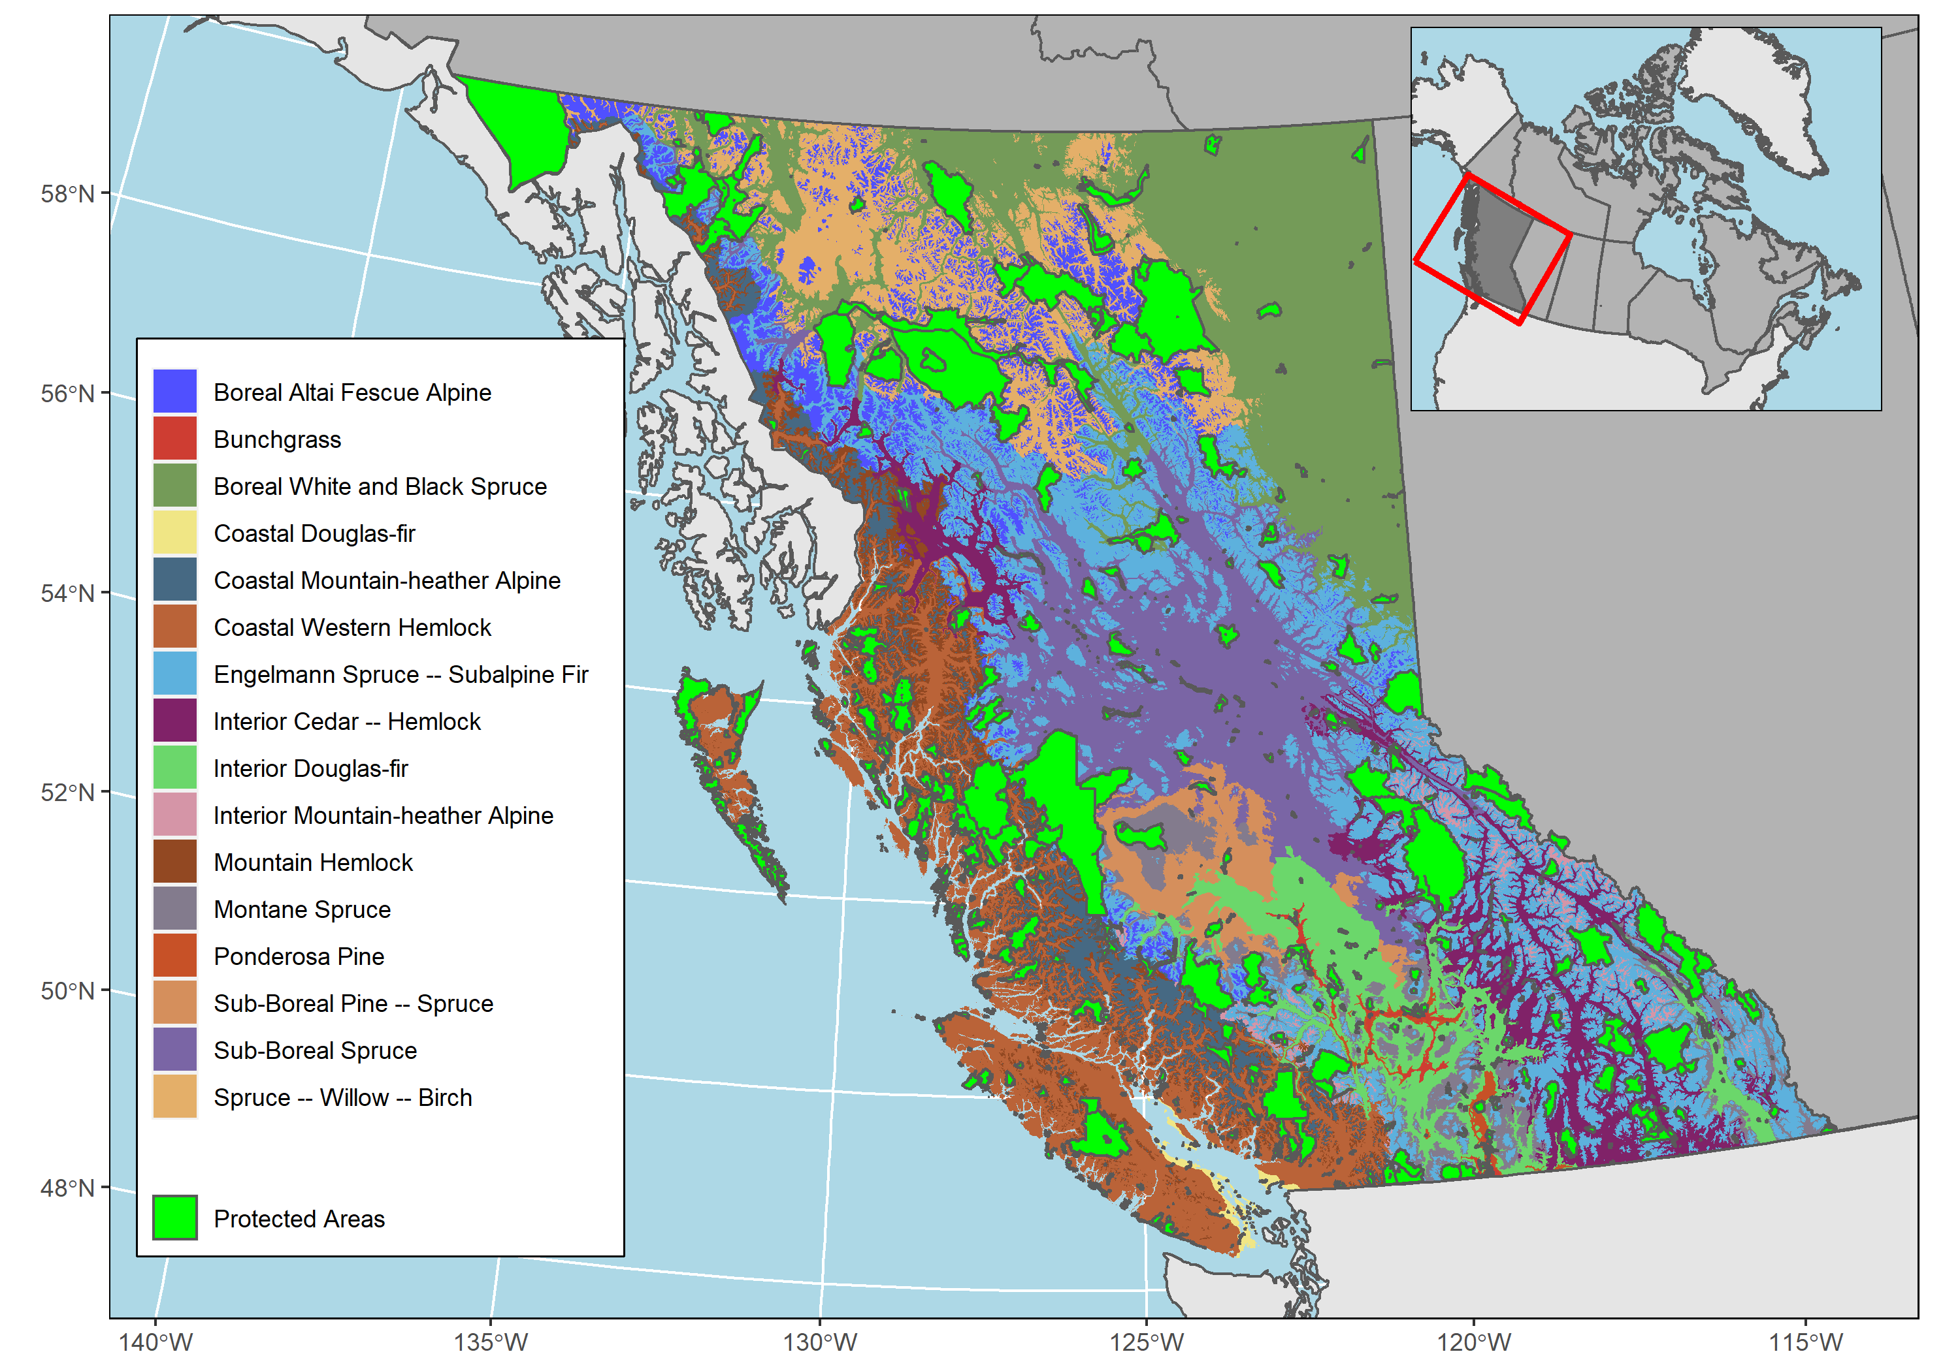

Figure 1: Terrestrial British Columbia including BEC zones and the location of PA selected in this study.

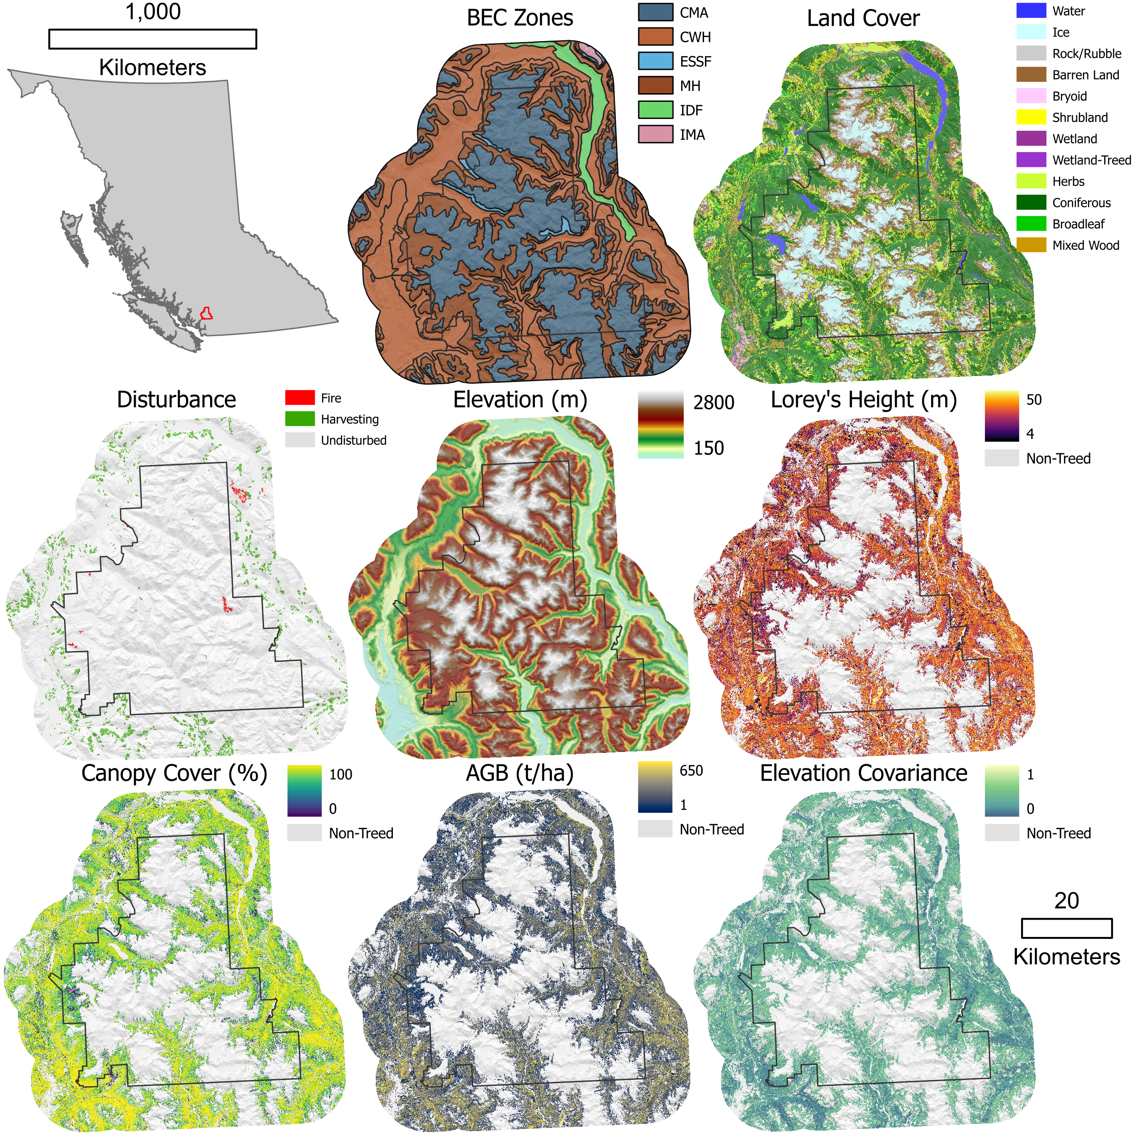

Figure 2: Visualizations for all layers included in the analysis for Garibaldi Park and surrounding region (red outline) in BC for 2015.

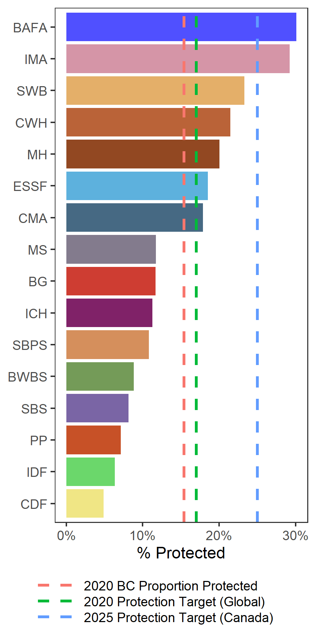

Figure 3: Areal proportion of biogeoclimatic ecosystem classification (BEC) zones protected in British Columbia (See Table 1 for full BEC zone names).

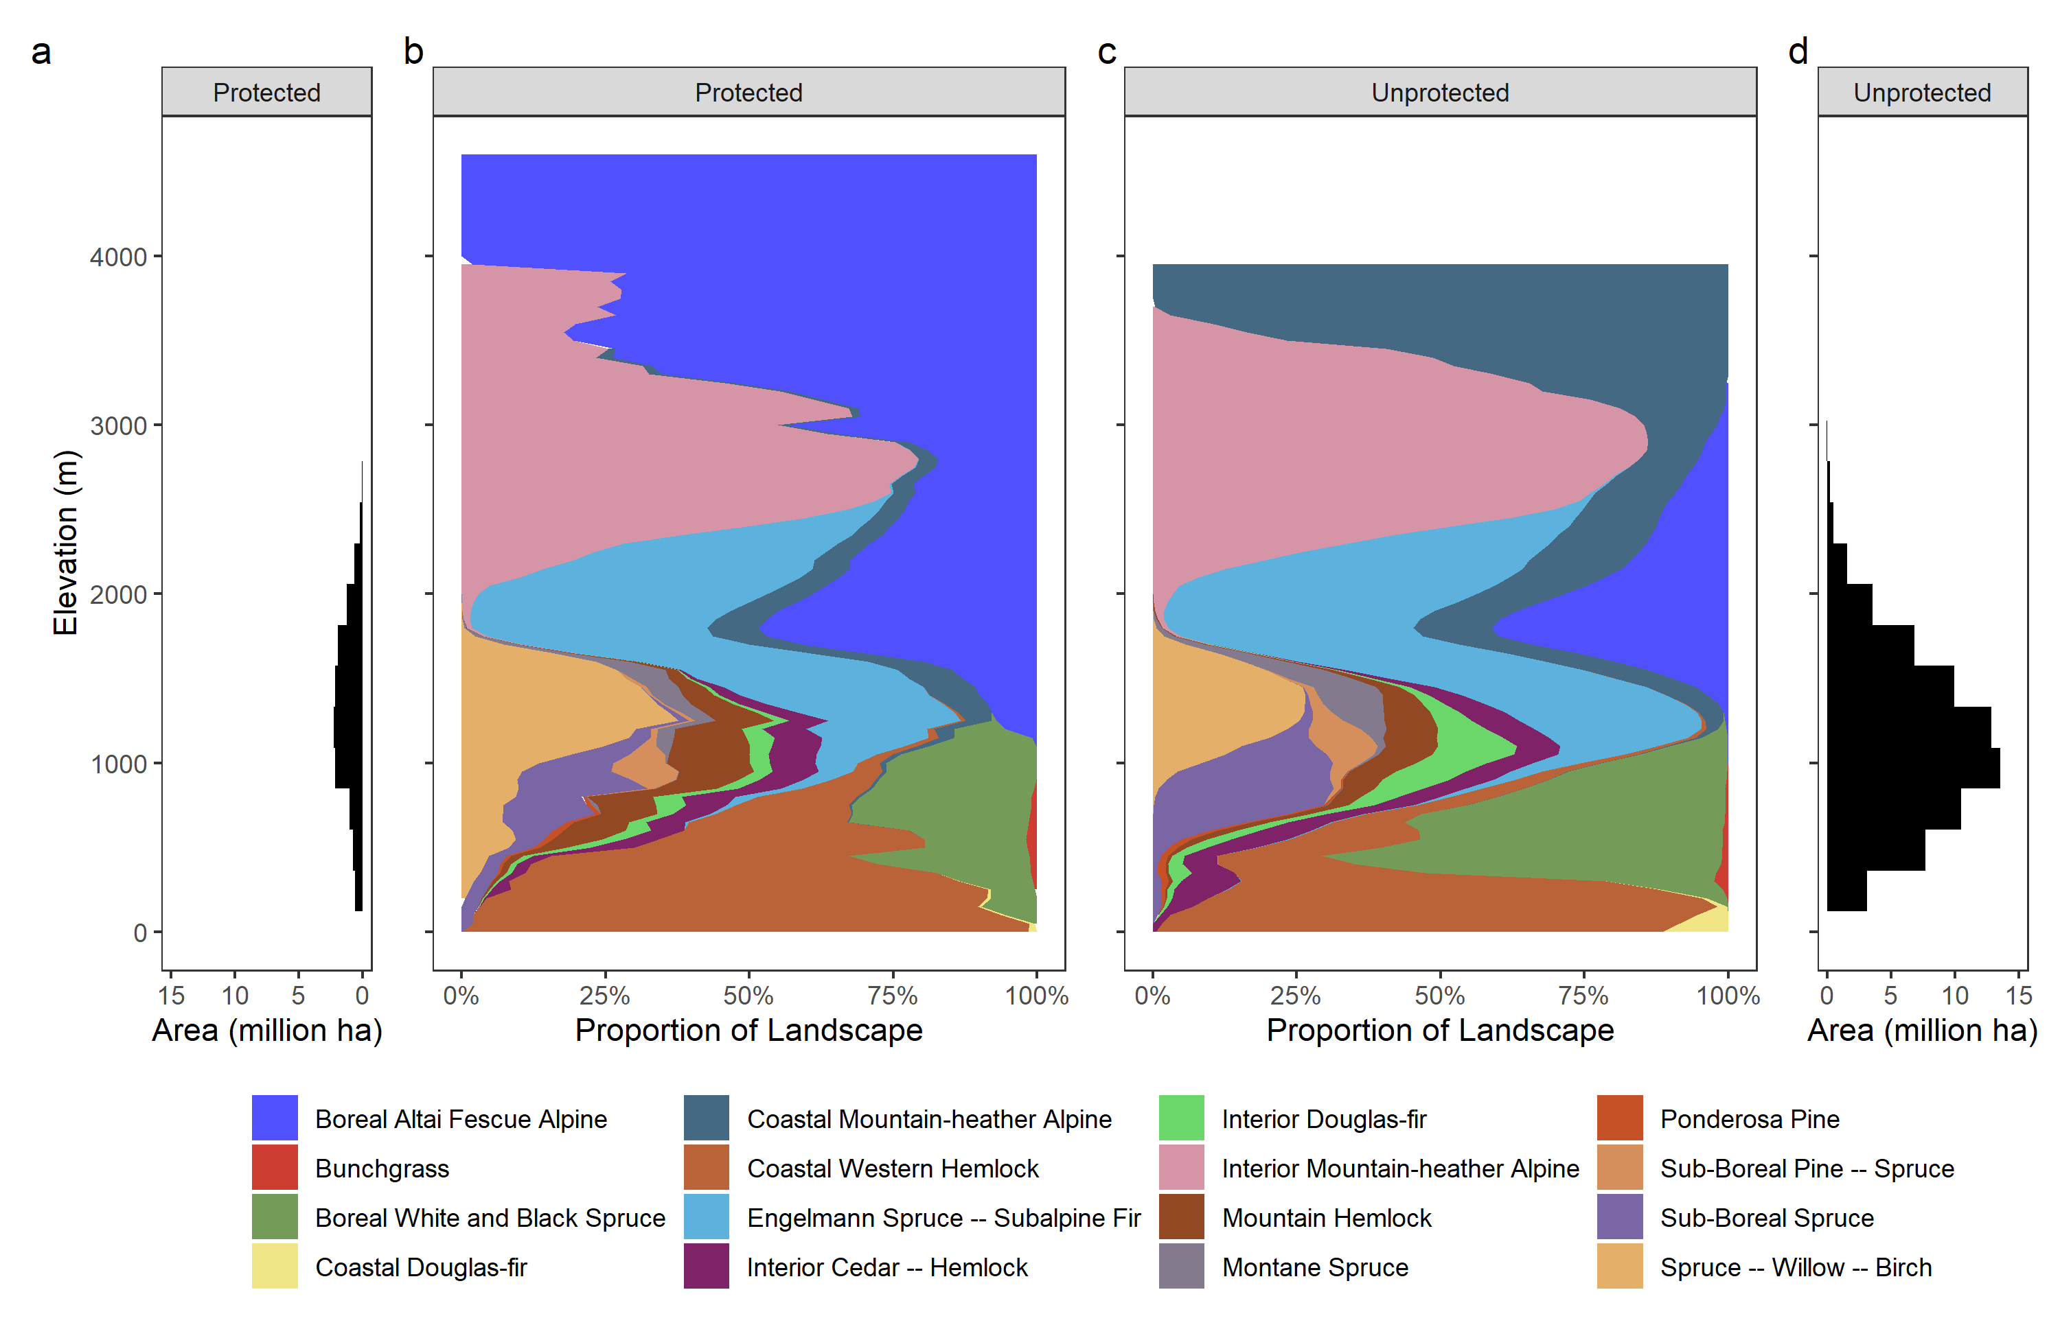

Figure 4: (a) Histogram of area protected in British Columbia by elevation. Proportion of Biogeoclimatic Ecosystem Classification (BEC) zone by elevation for both (b) protected areas, and (c) unprotected areas aggregated to a bin width of 50m. (d) Histogram of area unprotected in British Columbia by elevation.

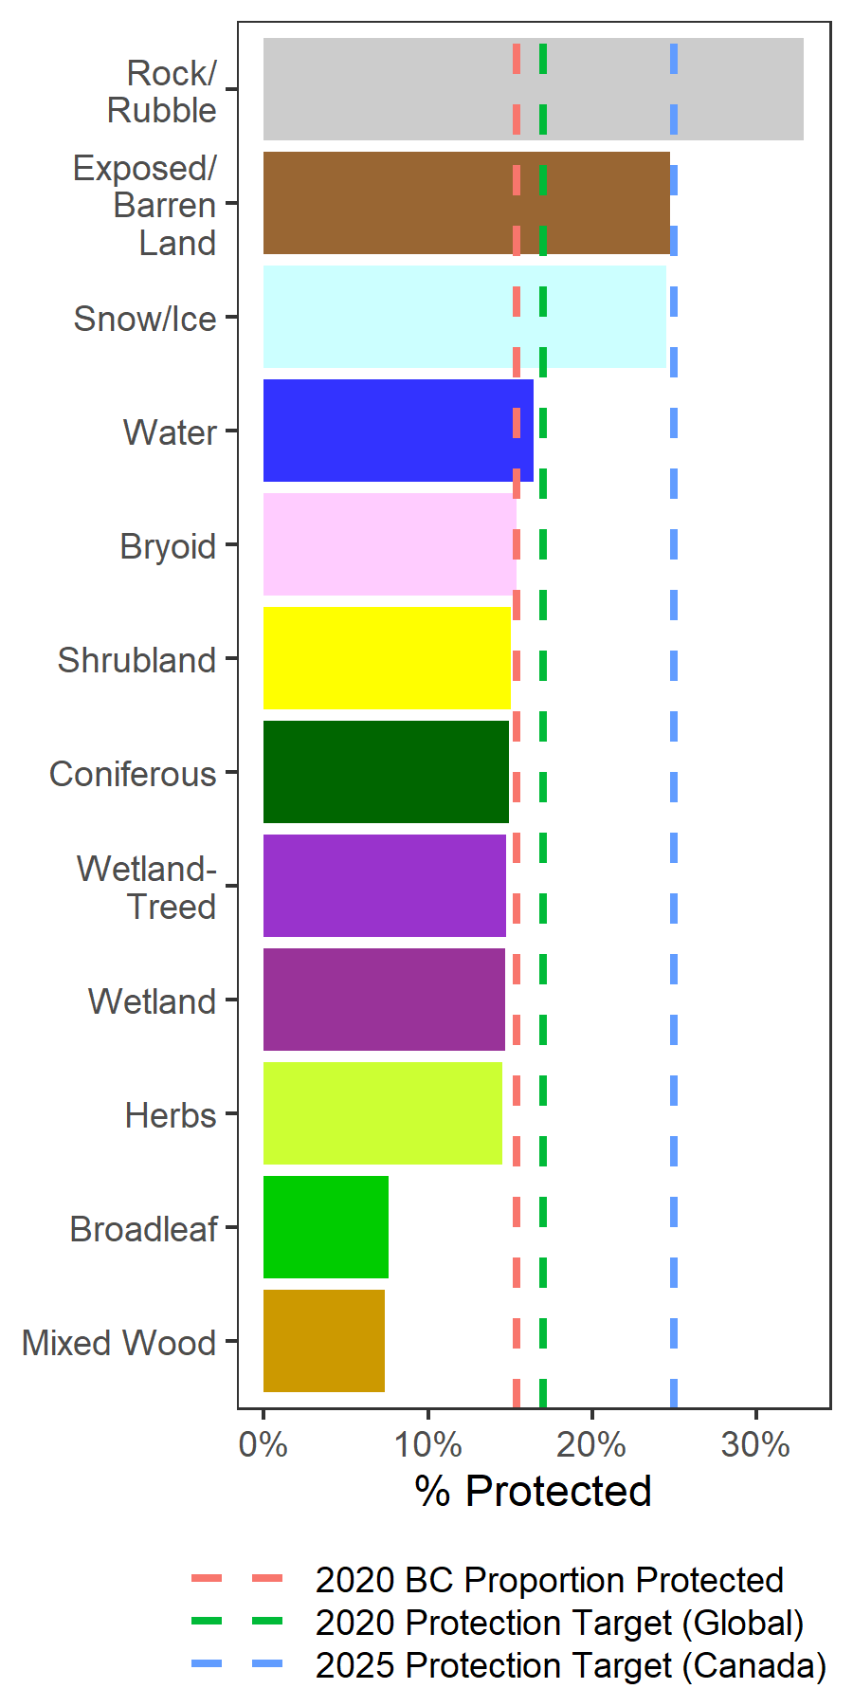

Figure 5: Areal proportion of land cover classes protected in BC.

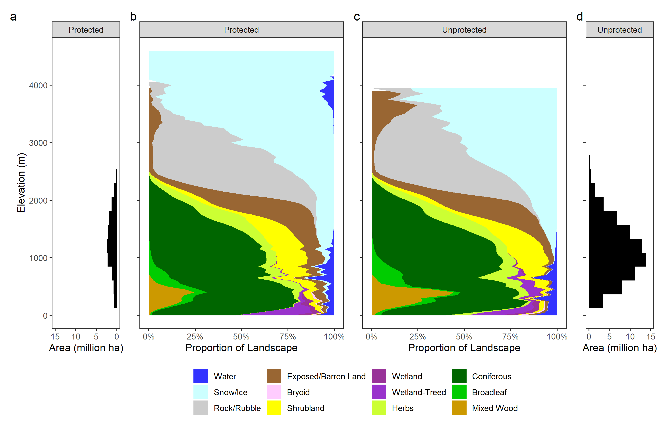

Figure 6: (a) Histogram of area protected in British Columbia by elevation. Proportion of land cover by elevation for both (b) protected areas, and (c) unprotected areas aggregated to a bin width of 50m. (d) Histogram of area unprotected in British Columbia by elevation.

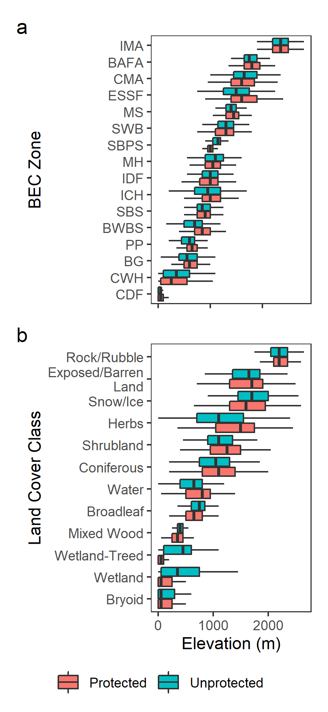

Figure 7: Elevation boxplots for BEC zones (a), and land cover classes (b). Whiskers indicate first quartile minus the interquartile range and third quartile to the interquartile range. Box and interior vertical line indicate first quartile, median, and third quartile, respectively.

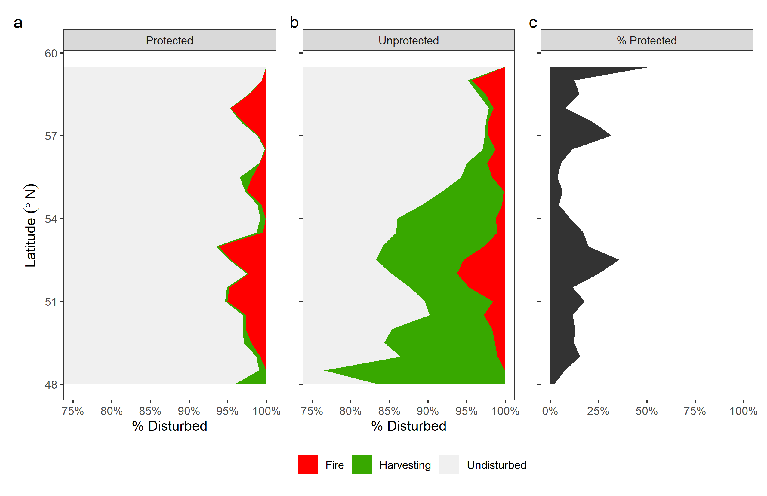  
Figure 8: Proportion of area disturbed by latitude from 1984 to 2019 in protected areas (a), and unprotected areas (b) aggregated to a bin width of 1°. Proportion of terrestrial area that is protected at each latitude (c).

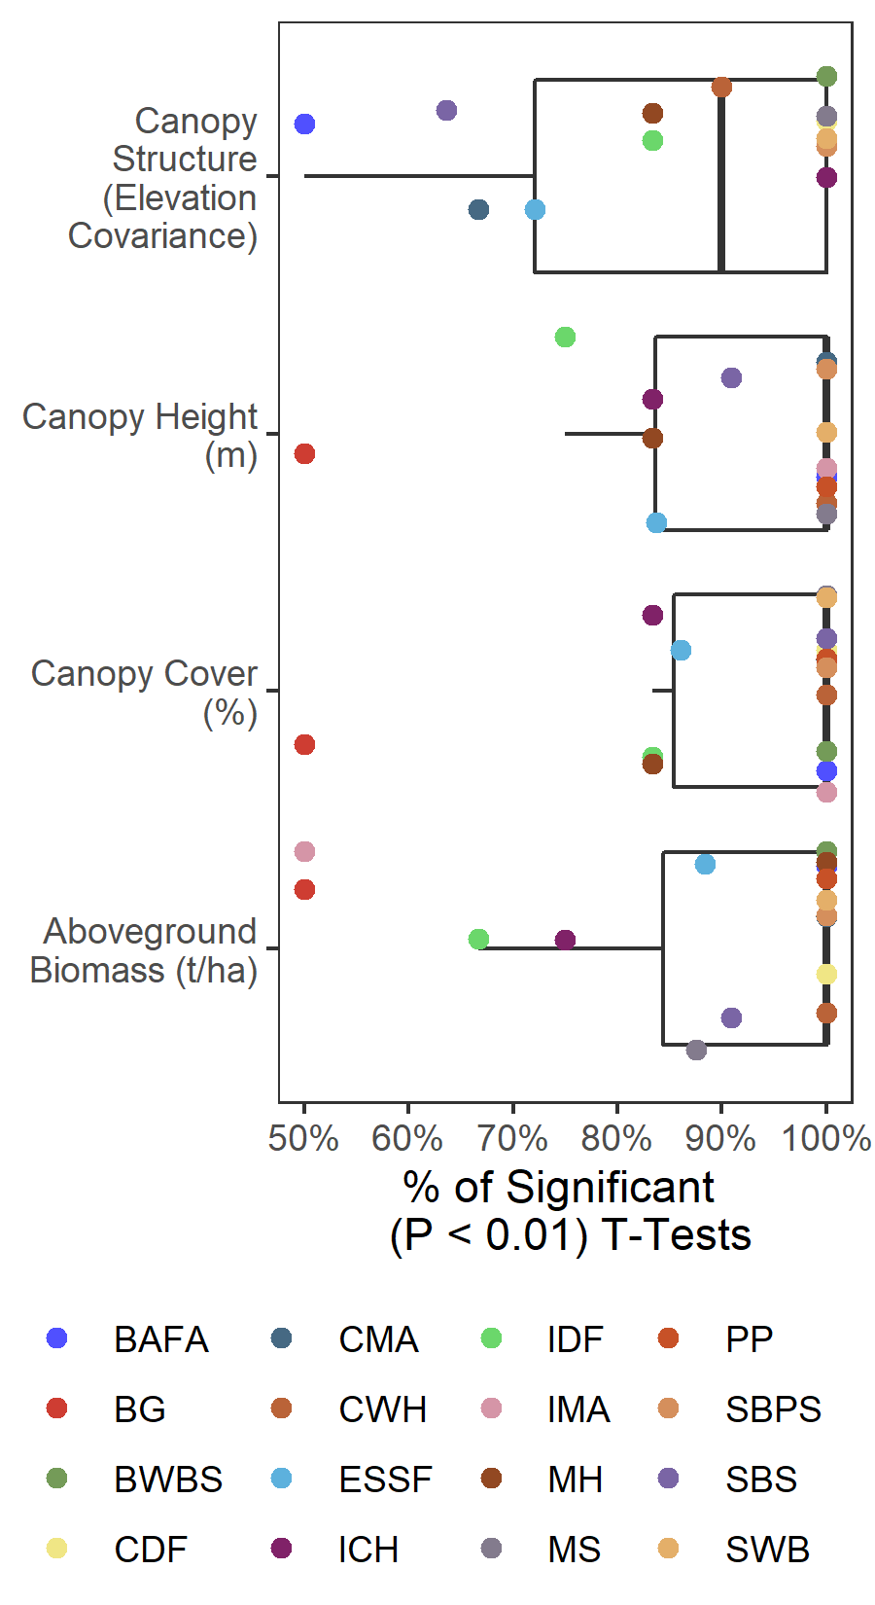

Figure 9: Summary of proportion of ecosystem subzone which have significant p-values from a two-tailed t-test with the Bonferroni correction (n = 496) applied at a significance level of 0.05. Boxplots represent median, interquartile range (IQR) and extreme values (1.5 × IQR).

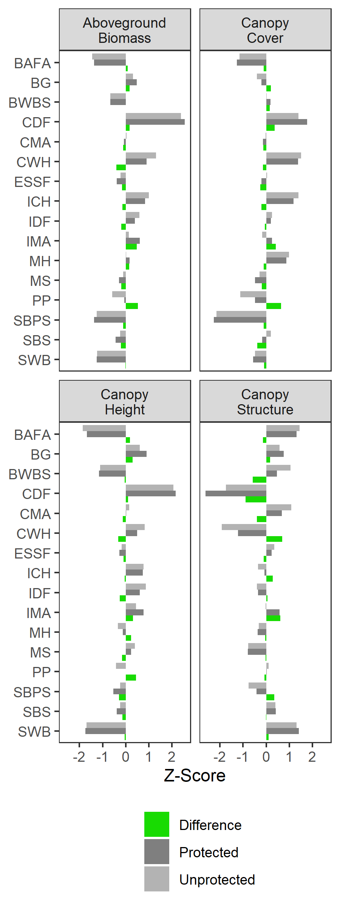

Figure 10: Z-Scores of forest structural attributes in PA, UA, and their differences across BEC zones in BC.